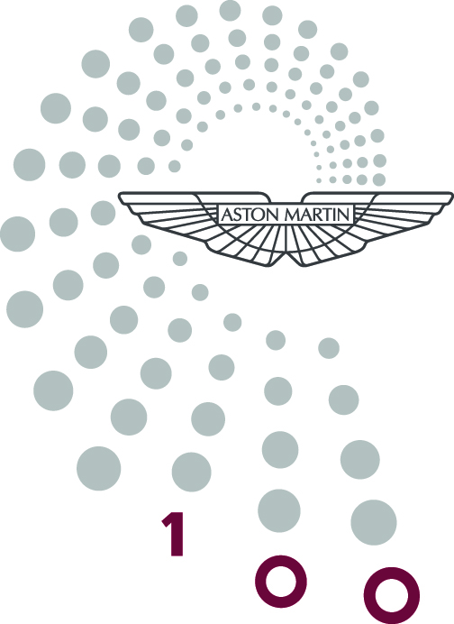
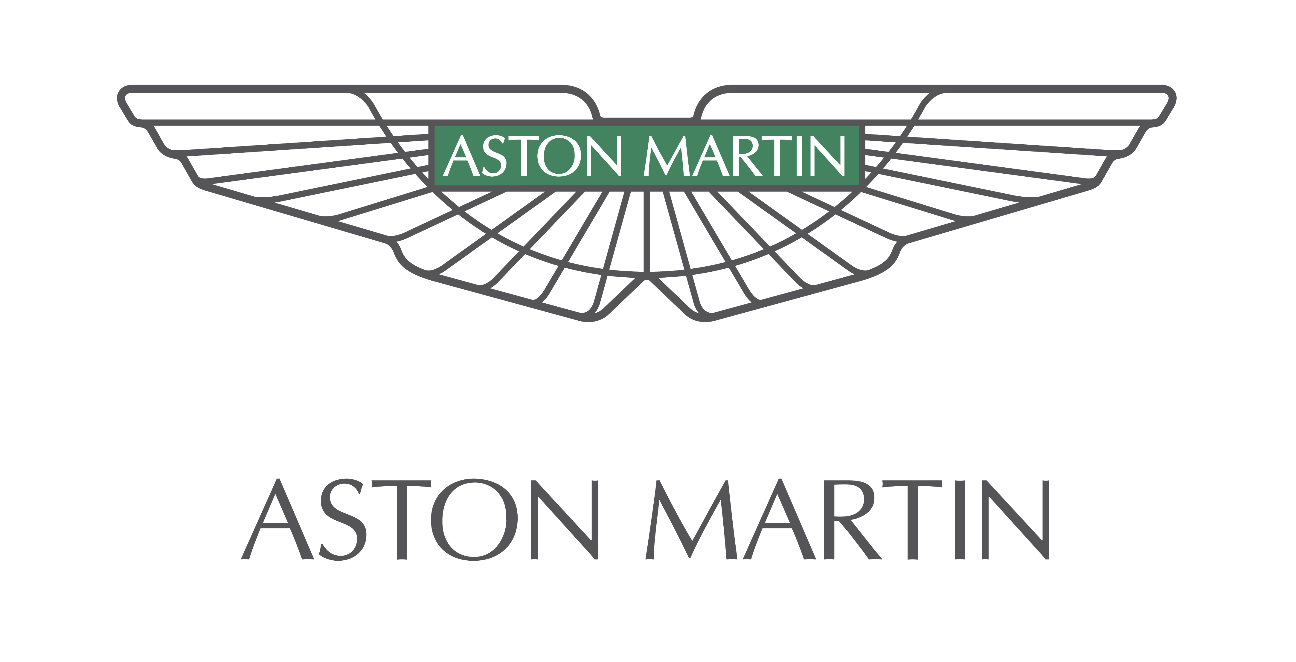
For release: 1pm GMT, Tuesday 15 January 2013

Aston Martin launches global celebrations marking a century of success

15 January 2013, Gaydon: British sports car maker Aston Martin launches its year of centenary celebrations today with a return to its roots in London.

The luxury brand is marking the official anniversary of its founding 100 years ago today with a ceremony in Chelsea’s Henniker Mews – the original home of the company that went on to become Aston Martin, founded on 15 January 1913.

Joining with the Aston Martin Heritage Trust to unveil a commemorative plaque at Henniker Mews, the sports car maker is lining up a special centenary edition of its new ultimate GT – the Vanquish – alongside the oldest Aston Martin in existence, A3.

Aston Martin CEO, Dr Ulrich Bez said: “I am proud to be celebrating 100 years of heritage and the best of British craftsmanship.

“Aston Martin is known around the world for our leading design combined with advanced technology. Ours is the coolest luxury car brand on the planet and I am looking forward to our second century of building the world’s most desirable sports cars.”

Speaking at the unveiling, Roger Carey, Chairman of the Aston Martin Heritage Trust said: “It’s fitting, I think, that we have both the newest and oldest Aston Martins in existence here at Henniker Mews, where this remarkable story began 100 years ago.

“This is where the workshops were first located and the Aston Martin Heritage Trust felt it was important to record the centenary by creating and displaying a plaque commemorating the start of such an iconic car business.”

Aston Martin Chairman, David Richards said: “It’s great to be back at the place where it all started. The Aston Martin story reaches a significant milestone in 2013 with our unique heritage and fiercely independent tradition inspiring exciting chapters yet to come.

“We look forward to sharing this milestone with our team, our partners, our customers and Aston Martin enthusiasts around the world.”

Today’s event in London marks the start of a year-long celebration of all things Aston Martin, with events taking place worldwide over the next 12 months.

In the UK, a week-long Aston Martin festival will take place from 15 July to 21 July. Designed to appeal to owners and enthusiasts of the brand, the Centenary Week will include ‘open house’ activities at Aston Martin’s exclusive Gaydon headquarters, including factory-based events and driving tours and will culminate in a 1,000-guest ‘birthday party’ on Saturday 20 July and a spectacular Centenary gathering in central London on Sunday 21 July.

This highlight of the centenary celebrations will be held in partnership with the Aston Martin Heritage Trust and the Aston Martin Owners Club will feature 100 of the brand’s most iconic cars in a multi-million pound timeline display. The event will also see one of the largest gatherings of Aston Martins in the 100-year history of the great British marque.

In addition, appearances at iconic events throughout 2013 including Nürburgring 24-Hours, Silverstone Classic, Villa D’Este, Le Mans 24-Hours and Pebble Beach will ensure that the celebration is truly global.

Dr Bez explained: “Aston Martin remains one of the most exclusive and sought-after brands in the world, so it’s right that our centenary celebrations take place around the globe this year.

“It’s appropriate that we mark the first 100 years of the company in this way and, with exceptional new cars like our ultimate GT – the Vanquish – timeless new DB9 and super-exclusive V12 Zagato, we clearly have a vibrant and exciting future ahead.”

Today’s London event recalls the day 100 years ago when founders Lionel Martin and Robert Bamford saw their new automotive venture incorporated as ‘Bamford and Martin Ltd’. Production of the very first Aston Martin car, known as 'Coal Scuttle' commenced soon after. The ‘Aston’ element was inspired by Lionel Martin’s passion for hill climb competitions, in particular the Aston Clinton hill climb in Buckinghamshire.

For further updates view the centenary web page and sign up to receive the newsletter www.astonmartin.com/100.
- Ends -
Notes to editors:

- things you didn’t know about Aston Martin:

- There have been 10 different versions of the iconic Aston Martin badge. The current version was introduced in 2003

- The Aston Martin wings badge has its origins in ancient Egypt – derived from the open wings of the scarab beetle

- In 100 years Aston Martin has produced just over 60,000 sports cars

- It is accurately estimated that more than 90% of all Aston Martins built are still in existence

- Aston Martin has manufactured cars from seven locations in the past 100 years

- Aston Martin’s global HQ at Gaydon, the company’s first purpose-built home, celebrates its tenth anniversary in 2013

- The Aston Martin Owners Club was founded in 1935 at The Grafton Hotel, London

- The now sold-out One-77 hypercar is Aston Martin’s most exclusive, powerful and expensive production model to date

- It took 2,700 man hours to produce each One-77

- The painting process for the current Aston Martin range takes between 50 and 70 hours per car

A3 – Aston Martin prototype (1921)
The first Aston Martin, named Coal Scuttle was built in 1914. Following Coal Scuttle and the Great War, three more prototype cars were built including Bunny (no longer in existence) and chassis number A3 which was the third Aston Martin ever built and the oldest in existence. The car is now owned by the Aston Martin Heritage Trust.
Aston Martin Timeline

- On 15 January 1913 Robert Bamford and Lionel Martin form Bamford and Martin Ltd, based in Henniker Mews, off the Fulham Road in London

- The first Aston Martin is registered on 16 March. It is christened ‘Coal Scuttle’ and powered by a 1389cc Coventry Climax engine

- The second prototype Aston Martin is developed at new premises at Abingdon Road, Kensington. It’s fitted with a 1487cc engine and front wheel brakes. It is the true forerunner to the first production cars

Count Louis Zborowski begins to invest in the company and Robert Bamford steps away

1922 An Aston Martin prototype nicknamed ‘Bunny’ breaks ten world records in 16 1/2 hours at Brooklands. It averages 76mph

Aston Martin fields two cars at the French Grand Prix on 16 July

1925 The company goes into receivership but is rescued by Lord Charnwood, John Benson, Augustus Cesare Bertelli and William Renwick. It is renamed Aston Martin Motors and relocates to Feltham, Middlesex

1932 Bertelli proves the speed and endurance of Aston Martin’s new range by winning the Biennial Cup at the Le Mans 24 hour race with Pat Driscol

Sir Arthur Sutherland becomes the new owner of Aston Martin and focuses his efforts on a new road car range

1935 The Aston Martin Owners’ Club is founded at The Grafton Hotel on Tottenham Court Road, London
1939 The highly advanced Atom prototype takes shape. It has an early type of spaceframe chassis, independent front suspension, an aerodynamic shape and a four-speed Cotal electric gearbox

1947 Engineering magnate David Brown answers an ad in The Times seeking an owner for a ‘high class motor business’ and buys Aston Martin for £20,000. Following the purchase of Lagonda he forms Aston Martin Lagonda

1948 A 2-litre Sports wins the Spa-Francorchamps 24-hour race

1949 Three DB2s tackle the Le Mans 24 hours, including one with a new 2.6-litre in-line six-cylinder engine designed by Willie Watson

1955 David Brown buys Tickford Motor Bodies in Newport Pagnell, Buckinghamshire. Production of Aston Martins begins to migrate to the new facility

1958 The DB4 is launched, powered by a new 3.7-litre in-line six cylinder engine designed by Tadek Marek. It produces 240bhp and propels the DB4 to 140mph. The four-seater body is designed by Carrozzeria Touring of Milan, using their 'Superleggera' construction method in which handmade aluminium panels are fixed to a tubular frame built onto a substantial platform chassis

1959 The DBR1 wins the World Sports Car Championship with victories in the Nürburgring 1000km and at Goodwood along the way. The crowning glory is outright victory at the Le Mans 24 hour with Carroll Shelby and Roy Salvadori at the wheel

1960 Aston Martin begins its long association with Milan-based coachbuilder Zagato. The DB4 GT Zagato features a 314bhp engine, acrylic windows and a super lightweight body. Only 19 are produced between 1960-1963

1964 Sean Connery as James Bond drives the new DB5 in Goldfinger and an iconic on-screen relationship is born

1972 David Brown sells Aston Martin and Company Developments take control. In a period of uncertainty Aston Martin changes hands again

1975 Canadian George Minden and American businessman Peter Sprague rescue the company from administration

1976 The controversial William Towns’-designed Lagonda is launched. It attracts a huge amount of publicity and sales are strong

1981 The company changes hands again, this time bought by Tim Hearley’s CH Industrial and Victor Gauntlett’s Pace Petroleum. Gauntlett becomes chairman and quickly begins to turn Aston Martin around

1984 Automotive Industrial becomes sole owners of Aston Martin but Gauntlett stays on in his role. He’s soon a shareholder again when shipping magnate Peter Livanos takes a 75% share and Gauntlett the remaining 25%

1986 The Vantage Zagato is launched and becomes one of the fastest supercars in the world with a top speed of 186mph. Just 52 Coupés and 37 Volantes are produced
1987 Ford Motor Company takes a 75% share of Aston Martin and later becomes sole owner. A period of rapid investment begins

1993 The Ian Callum-designed DB7 is unveiled at the Geneva Auto Salon. It goes on sale the following year and is produced at a new factory in Bloxham, Oxfordshire. The DB7 goes on to become the most significant Aston Martin to date and represents a turning point for the company

1993 The 550bhp Vantage is launched to great acclaim

1999 DB7 Vantage Coupe and Volante versions are produced using the first V12 production engine for Aston Martin

2000 A new era begins under Dr Ulrich Bez, who becomes Chairman and CEO. His vision of a modern Aston Martin will mark the beginning of the most successful period in Aston Martin’s history

2001 A new supercar utilising a bonded aluminium chassis and body with carbon fibre composites is launched. The V12 Vanquish sets a new blueprint for Aston Martin

2003 Aston Martin’s new global headquarters is opened in Gaydon, Warwickshire. It’s the first purpose-built facility in the company’s history

2003 DB9 production gets underway at Gaydon – the first car to use VH architecture

2004 Aston Martin’s engine plant in Cologne, Germany commences production of all V12 and V8 engines

2005 The DBR9 marks a return to the racetrack. It will go on to secure class victories at Le Mans in 2007 and 2008

2007 A new chapter in the company’s history is written as Aston Martin returns to independence. The Ford Motor Company sells Aston Martin to a consortium of two international investment houses, Investment Dar and Adeem Investment, led by Chairman David Richards

2009 The rapid development of the brand continues. The four-door Rapide is unveiled at the Frankfurt Motorshow and the V12 Vantage and DBS Volante are launched. Aston Martin also unveils the ultimate expression of the marque, the One-77. On its debut the One-77 wins the Design Award in the Concepts and Prototypes Class at the Concorse d’Eleganza, Ville d’Este, Italy

2011 An historic partnership is rekindled with the launch of the V12 Zagato at the Concorso d’Eleganza, Ville d’Este, Italy. It also went on to win the Design Award in the Concepts and Prototypes Class at the Concorse d’Eleganza

2012 The iconic Vanquish name returns for a new flagship. This ultimate grand tourer combines world-leading design, industry-leading technology and advanced engineering to create a car that is the best Aston Martin in history

Brand communications contacts:

Janette Green, Director, Brand Communications
Tel: +44 (0)1926 644 444 Mobile: +44 (0)7766 471555

Sarah Calam, Corporate Communications Manager
Tel: +44 (0)1926 644198 Mobile: +44 (0)7795 240989

Scott Fisher, Product Communications Manager
Tel: +44 (0)1926 644854 Mobile: +44 (0)7764 386358

Melanie King, Lifestyle Communications Manager
Tel: +44 (0)1926 692641 Mobile: +44 (0)7585 906938

Kevin Watters, Press Officer, Product Communications
Tel: +44 (0)1926 644850 Mobile: +44 (0)7764 386683

Grace Barnie, Press Officer, Corporate and Internal Communications
Tel: +44 (0)1926 644852 Mobile: +44 (0)7880 903490

